1. Why we are taking this sessions?
2. We don’t need to learn everything in one Go.
3. Feel free to take notes I will also be sharing the same
4. Why we need Git and Git Hub ?
5. What is difference between Git and Git Hub ?
6. Setup, do you have Git Hub account and VSCode ?
7. After downloading Git in git bash run this two commands
8. git config --global user.email "your-email@example.com"
9. git config --global user.name "your-github-account-username"
10. git config --global core.editor "code --wait" this command will be used only if you are using vs code as your editor.
11. Now to check whether email and username is set, we will run the command

“ git config --list ” in the end part of output of this command will show your user email and user name which indicates successful setup.

1. File structure of current branch will get copied into the new branch which you create a new branch.
2. “ git branch new-branch-name ” this will create a branch with the name

“new-branch-name”

1. To move from one branch to another we will use the git command

“git switch branch-name-in-which-you-want-to-switch” using this command you will switch into the branch named as “branch-name-in-which-you-want-to-switch”

1. In order to save a file we have to run 2 commands mentioned below
2. “git add file-name-1 file-name-2” this will add files into staging area or you can use

“ git add . ” to add all modified and untracked files at once into staging area.

1. “ git commit -m “my-commit-message-in-double-quotes” ” this is the final step to save your file into your local machine.
2. In order to update all your local machine changes into the repository on github you need to use the command “git push origin current-branch-name” using this command all changes of the branch named as “current-branch-name” will be sent and saved in to the repository on github.
3. In order to update all your local machine code according to the repository on github you need to use the command “git pull origin current-branch-name” using this command all content of the branch named as “current-branch-name” will be applied on local machine according to the branch’s repository content from github.
4. Connecting to git repo using “git clone” easiest method.

First you have to create an repository on github and then copy it’s https url

Then use the “ git clone copied-url ” git command to clone the repository.

Now move to the folder created which will be having the same as your repository using

Command “cd folder-name” now you can start working with your code. You don’t need to perform the command “git inti” when you use the clone method you can directly use git status command to check current status.

1. Before creating a git repository in any folder always compulsorily check whether there exists any other git repository in it already created, by using the command “git status” since if you create a new repository on a preexisting repo, you might loss the previous checkpoint and commits of the preexisting repo.
2. Now if there is no repository in the folder we will create a new repo using the command “git init” which stands for git initialization.
3. “git branch -m current-branch-new-name” to rename branch
4. Merge conflict example

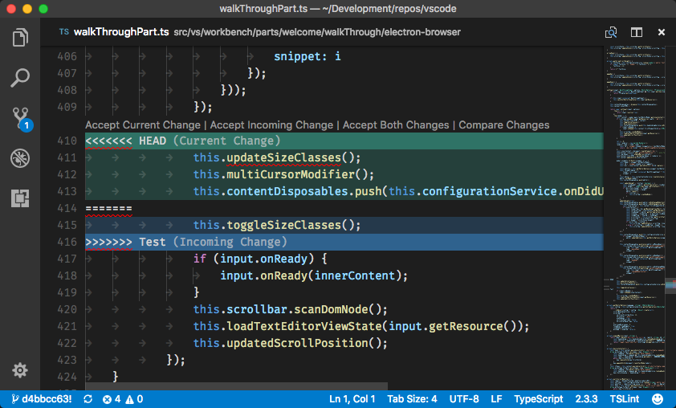

1. “ git log ” command will show you the history of commits with all details and hash code of commit.
2. “ git log --oneline ” command will show you the history of commits in a concise format.
3. “ git reflog ” will give you whole history of commit of branch when you switch to a specific commit state.
4. “ git reset –hard commit-hash ” this command is used to go in the state of specific commit. Please note before the word “hard” in the command there is double hyphen and “ commit-hash ” is the hash code of the commit
5. .gitignore
6. fork